SMART public restroom

***ABSTRACT***

***In the cutting edge world, the advances are definitely grown, yet at the same time the cleanliness in our nation is under risk. The abstract of this paper is to deliver clean and hygiene toilets. All the public toilets should be clean and hygiene. In our country, our government has introduced the scheme called “Swatch Bharat” (Clean India). Keeping the toilets uncontaminated is the one of the objective of Clean India scheme. This paper can be helpful to encourage the clean India project. In future, it can show the major part in clean India scheme. In an Existing system, they are focused only on identifying the dirt in the toilets. In our proposed system, we have determined on keeping clean toilets, observing the sweeper’s working activities. It can dodge many syndromes. It may create the consciousness amongst people about the toilet management. Therefore, our development is to use safe and hygienic toilets. This paper is based on IOT and image-processing concepts using different sensors like smell sensor, IR sensor, sonic sensor, RFID reader. By using these sensors, we can create the smart toilets****.*

***Keywords*:** *Smell sensor, IR sensor, sonic sensor, RFID reader, IOT*

# INTRODUCTION

In our country, people do not have enough knowledge of using toilets. This leads to several diseases, such as Malaria, Hepatitis, Flu, Cholera, Streptococcus, Typhoid, etc. Hence we introduce the concept in the IOT called "**Swatch Shithouse**" The term Swatch means ‘Clean’. Then the term Shithouse means ‘Toilet’. It is introduce to use and maintain the toilets in the clean and hygienic way. The project is based on IOT concepts using different sensors like smell sensor, dirt sensor, sonic sensor, RFID reader, Database. Using these materials we are trying to provide the clean toilets and create the awareness among the people.

## SCOPE OF THE PROJECT

In this paper we are going to provide the clean toilet. This paper can create the awareness among the people about the clean and hygienic toilets. This paper can ensure the responsibilities of the sweeper. Finally, this concept is the one of the stepping stone to the “Clean and disease free India”.

## EXISTING SYSTEM

In an existing system, they concentrate more on organizing sewages from the railway system. They are trying to taking all the medical tests through the usage of toilets. They are concentrated on reducing water wastage on toilets, by the implementation of

Automatic flusher.

**Disadvantages:**

* They are not focused on providing clean and hygienic toilets.
* The medical test can have chance to produce fault results.

### WORKING PRINCIPLE

* In the first phase, IR sensor is used to discover the dirt present in the toilet.
* Here the set of sample images are given as input.
* After using the toilet, the sensor senses the basin of the toilet.
* Then it relates the sensed image with the input image.
* If the dirt present, it increases the alarm.
* Then the user wants to be clean the waste. Through this activity, people can get the awareness about the toilet management.
* In the second phase, Figaro sensor is used to perceive the unwanted gases present in the toilet.
* In the Figaro sensor, a particular range is to be stable earlier manner. If the range gets extended, it can send the alert message to the sweeper. Then they cleaned it by using proper fragrant.
* In the third phase, RFID reader (Radio

Frequency Identification) is used to observe the sweeper’s activities (absence and presence in the toilet cleaning).

* Initially, the sweeper wants to show his/her individuality tag in front of RFID reader. It can be shown before and after cleaning the toilet.
* Then the first phase gets initiated and senses for the dirt presence in the toilet.
* If the dirt gets noticed, it raises the alarm.
* Through this monitoring activity, the sweeper can realize their roles and responsibilities. Then they protect the people by disposing all the unwanted materials (dirt, unwanted gases) present in the toilet.
* In the final phase, the sonic sensor is used to detect the depth of the septic tank.
* Here, the range of septic tank is fixed prior manner.
* If the sewage reached with the range, then it directs message to an organization.
* All the message transfer can be done by the GSM (Global System for Communication).

## ARCHITECTURE OF THE PROPOSED SYSTEM

### Architecture of the proposed system

**DESCRIPTION OF ARCHITECTURE HARDWARE REQUIREMENTS:**

* Microcontroller
* Power supply
* LCD display
* Buzzer
* Infrared sensor
* Sonic sensor
* Gas sensor
* RFID
* GSM modem

### SOFTWARE REQUIREMENTS

* Embedded C
* Python programming

### MICROCONTROLLER

A microcontroller is a small computer on a single combined circuit holding a processor core, memory and programmable input/output peripherals. Program memory in the form of Ferroelectric RAM, NOR flash or OTP ROM is also often included on chip, as well as a typically small amount of RAM. Microcontrollers are designed for embedded applications, in contrast to the microprocessors used in personal computers or other general-purpose applications.

### Microcontroller

PIC 16F877 is one of the most advanced microcontroller from Microchip. This controller is commonly used for experimental and modern applications because of its low price, wide range of requests, high quality, and ease of obtainability. It is ideal for applications such as machine control applications, measurement devices, study purpose, and so on. The PIC 16F877 features all the mechanisms which present microcontrollers usually have.

### LCD

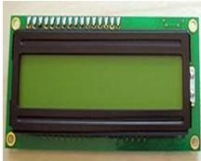LCD stands for Liquid Crystal Display. By using the LCD, all the outputs are displayed. LCD doesn’t know about the content (data or commands) supplied to its data bus. It is the user who has to specify whether the content at its data pins are data or commands.

### Figure 3: LCD Display

For this, if a command is inputted then a certain arrangement of 0s and 1s has to be applied to the Control lines so as to specify it is a command on the other hand if a data is inputted at the data lines then an another combination of 0s and 1s has to be applied to the control lines to require it is Data.

# BUZZER

Buzzer is also called as Beeper. It is a sound signaling mechanical device.

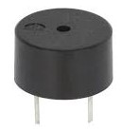

**Buzzer**

# INFRARED SENSOR

The IR sensor is used to detect the dirt present in the toilet. Here we nourish the image models into the sensor. It can perceive the dirt by comparing the images we feed into it, after using the toilet. If it can detect the dirt, it raises the alarm, and the users may get embraced and they clean it. This system can create the responsiveness among the people.

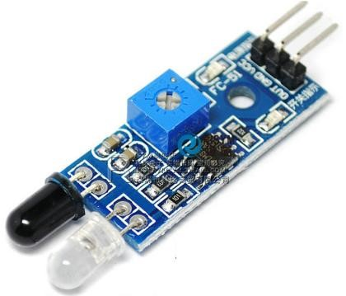

**IR sensor**

# SMELL SENSOR

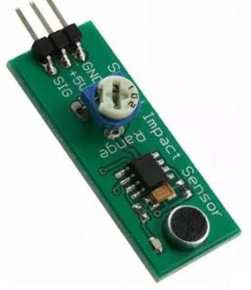The Smell Sensor is used to detect the unwanted smell and gases in the toilet. For this purpose, we are going to use the sensor called **Figaro** sensor.

## Smell Sensor

It cans intellect the dry gases present in the toilets such as NH3, CO2, CH4, H2S, etc. By taking those gases leads to Nausea, Drowsiness, instant loss of awareness, etc. After sensing the unwanted gases, it can blink the red light. Then the sweeper can clean it by using particular Cleaning Agents.

# RFID READER

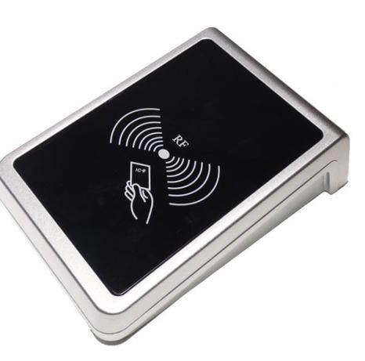The RFID stands for Radio Frequency Identification. It can be used for monitoring the Sweeper. The Organization wishes to provide the identity tag for the Sweeper. The Sweeper desires to show the tag before the cleaning process is going to start and after it is finished.

**RFID Reader**

Then the CR4 sensor can spot the presence of dirt. If it is present, it can blink the red light. If it is clean, it can blink the blue light. It assistances to understand the responsibilities of sweeper by his/her own. If Sweeper is not clean the toilets for period of time, his/her absence in cleaning the toilet also reported to the dependable organization. These all the details are stored in the database.

## SONIC SENSOR

The Sonic Sensor is used for computing the depth. Here it is used to measure the depth of the septic tank. The Sonic Sensor is fixed into the Septic tank. Then the Septic tank get filled means, it can sends the communications to particular organization. Then they will allot persons to clean the septic tank. Then septic tank cleaners will clean the tank. After cleaning it, the sensor can detect the level, and send messages to consistent organization.

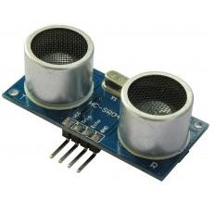

## Sonic sensor

This ultrasonic sensor can be used for measuring distance, object sensor, motion sensors etc.

High sensitive module can be used with microcontroller to integrate with motion circuits to measure the distance, position & motion sensitive products.

In a nutshell, water depth sensing is using a sensor to measure the depth of water in a tank or container. Although various sensors can be used for this application, we will talk about ultrasonic sensor application.

With ultrasonic sensors, we can find the water depth calculation by finding the distance between the transceiver and the surface of the water. The sensor will transmit a short ultrasonic pulse, and we can measure the travel time of that pulse to the liquid and back. We can then subtract that distance from the total depth of the tank to determine the water depth.

**BLOCK DIAGRAM:**

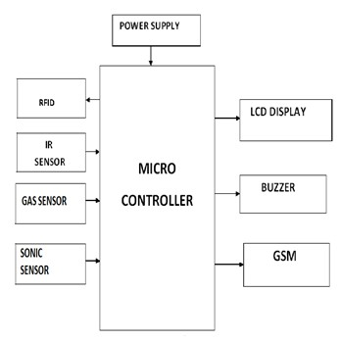

**Block diagram of the proposed system**

## GSM

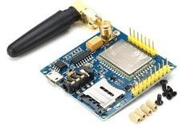GSM stands for Global System for Mobile communication. It establishes the mobile communication from one place to another place.

### GSM Module

It transfers the information from main circuit to operator. It uses Time Division Multiple Access (TDMA).

GSM is mainly used for communicating and transferring message from one person to concerned organization. GSM module is used to establish communication between a computer and a GSM and GPRS system.

Here we are using GSM LT-2 communication module makes it possible to use GSM paths to provide monitoring and messaging functions in alarm systems. It facilitates cooperation with SATEL and third party control panel dialers or correctly configured outputs.

He GSM LT-2 module makes it possible to implement monitoring as well as text and voice messaging functions. The caller ID retransmission function creates it likely to present the incoming callers number on telecommunication stations armed with this functionality.

GSM alarm system built-in GSM communication module inside, work as a mobile handset. After purchased the GSM alarm system, people need to acquisition the SIM card, and select the mobile service package. GSM alarm system can program several phone numbers for alarm receiving. When any abnormal event happens, the system will response, then inform the owner via voice call and short message (SMS).

GSM will check the messaging activities for sweepers and also need to check with their cleanliness duty for their work. The sweepers need to check with particular activity of its work by their sensors.

### WORKING MODEL

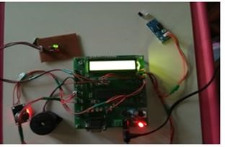

**working model**

This is the module of the proposed system. Here the sensors are connected with the microcontroller.

#### DIRT DETECTION

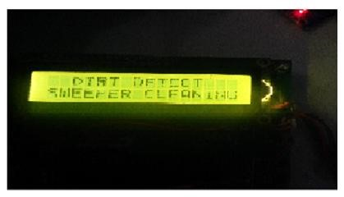It shows the dirt detection in the toilets.

**Output module, while detecting the dirt**

#### SMELL AND DEPTH DETECTION

It shows the smell detection and depth detection.

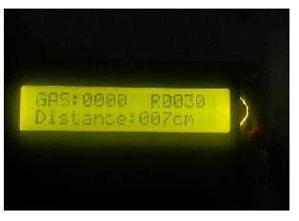

**Output module, while detecting the Gas and the distance.**

#### MONITORING SWEEPER ACTIVITIES

It shows the sweeper activities.

**Indicates the sweeper presence**

**ADVANTAGES**

* It can creates an awareness among the people about the proper toilet management
* It can prevents the many contagious diseases like malaria, typhoid, cholera, streptococcus, asthma, etc.
* It can promotes the “Swachhbharat” scheme

**PROGRAM CODE**

**C PROGRAM**

#include <stdio.h>

#include <wiringPi.h> // Library for GPIO control (on Raspberry Pi)

#include <wiringPiI2C.h> // Library for I2C communication

#include <unistd.h>

#include <MFRC522.h> // Library for RFID reader

// GPIO pins for sensors (change these to match your setup)

#define SMELL_SENSOR_PIN 17

#define IR_SENSOR_PIN 18

#define SONIC_TRIGGER_PIN 23

#define SONIC_ECHO_PIN 24

// Function to read data from the smell sensor

int read_smell_sensor()

{

// Add your code here to read from the smell sensor

// and return the data.

return 0;

}

// Function to read data from the IR sensor

int read_ir_sensor() {

// Add your code here to read from the IR sensor

// and return the data.

return 0;

}

// Function to read data from the sonic sensor

int read_sonic_sensor() {

// Add your code here to read from the sonic sensor

// and return the data.

return 0;

}

int main() {

wiringPiSetup(); // Initialize wiringPi library (Raspberry Pi GPIO)

// Setup GPIO pins for sensors

pinMode(SMELL_SENSOR_PIN, INPUT);

pinMode(IR_SENSOR_PIN, INPUT);

// Setup GPIO pins for sonic sensor (if using WiringPi)

pinMode(SONIC_TRIGGER_PIN, OUTPUT);

pinMode(SONIC_ECHO_PIN, INPUT);

// Initialize RFID reader

MFRC522 mfrc522(0, 0);

while (1) {

// Read data from the smell sensor

int smell_data = read_smell_sensor();

// Read data from the IR sensor

int ir_data = digitalRead(IR_SENSOR_PIN);

// Read data from the sonic sensor

int sonic_data = read_sonic_sensor();

// Read data from the RFID reader

if (mfrc522.PICC_IsNewCardPresent() && mfrc522.PICC_ReadCardSerial()) {

printf("RFID Tag UID: %X %X %X %X\n",

mfrc522.uid.uidByte [0], mfrc522.uid.uidByte [1],

mfrc522.uid.uidBIyte [2], mfrc7522.uid.uidByte [3]);

}

delay(1000);

}

return 0;

}

**PYHTON CODE**

import RPi.GPIO as GPIO

import time

import smbus

import RPi.GPIO as GPIO

from mfrc522 import SimpleMFRC522

import os

# Initialize RFID reader

reader = SimpleMFRC522()

# Set up GPIO mode for IR and sonic sensors

GPIO.setmode(GPIO.BCM)

# Define pin numbers for IR and sonic sensors

IR_SENSOR_PIN = 18 # Change this to the appropriate GPIO pin

SONIC_TRIGGER_PIN = 23 # Change this to the appropriate GPIO pin

SONIC_ECHO_PIN = 24 # Change this to the appropriate GPIO pin

# Set up GPIO pin modes

GPIO.setup(IR_SENSOR_PIN, GPIO.IN)

GPIO.setup(SONIC_TRIGGER_PIN, GPIO.OUT)

GPIO.setup(SONIC_ECHO_PIN, GPIO.IN)

# Function to read IR sensor

def read_ir_sensor():

return GPIO.input(IR_SENSOR_PIN)

# Function to read sonic sensor

def read_sonic_sensor():

GPIO.output(SONIC_TRIGGER_PIN, True)

time.sleep(0.00001)

GPIO.output(SONIC_TRIGGER_PIN, False)

start_time = time.time()

end_time = time.time()

while GPIO.input(SONIC_ECHO_PIN) == 0:

start_time = time.time()

while GPIO.input(SONIC_ECHO_PIN) == 1:

end_time = time.time()

pulse_duration = end_time - start_time

distance = (pulse_duration * 34300) / 2

return distance

try:

while True:

# Read data from the smell sensor (use your specific code for this sensor)

smell_data = read_smell_sensor()

# Read data from the IR sensor

ir_data = read_ir_sensor()

# Read data from the sonic sensor

sonic_data = read_sonic_sensor()

# Read data from the RFID reader

try:

print("Hold an RFID tag near the reader...")

id, text = reader.read()

print(f"RFID Tag ID: {id}")

print(f"RFID Tag Text: {text}")

except Exception as e:

print("Error reading RFID:", e)

# Perform actions based on sensor data

# You can add your own logic here

time.sleep(1) # Read sensors every 1 second

except KeyboardInterrupt:

GPIO.cleanup()

**THOSE PROGRAM ARE EXECUTED SUCCESEFULLY**

**CONCLUSION**

Our proposed project will create awareness among the people about the proper sanitation. It makes use of Internet of things, which is a rapidly growing technology. Our proposed system will make everyone to strictly follow the cleanliness and proper sanitation in the toilets. It prevents the many new contagious diseases that spread due to improper sanitation of the toilets. Thus by using technologies in the smarter way, we can maintain the cleanliness which is next to the godliness. Keep Clean, Be Safe.